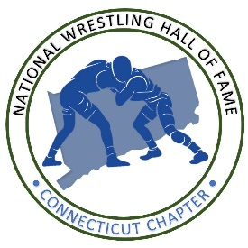

**Connecticut Chapter**

**2025 National Wrestling Hall of Fame induction dinner**

**Date:** Saturday, April 26, 2025

**Time:** 4 p.m.

**Location:** Mohegan Sun and Casino Resort, Uncas Ball Room

**Tickets:** $150 through TicketSpice: See QR code at bottom of page

Yes, I’d like to purchase an ad for:

(Inductee’s Name)

**Banquet Program Advertisement options:**

Full page (8½ x 11) advertisement or message of personal congratulations $300

Half page (8½ x 5½) advertisement or message of personal congratulations $175

Quarter page (4.25 x 5½) advertisement or message of personal congratulations $100

Message of personal congratulations to an inductee (50 word maximum) $50

**Please supply copy and camera-ready artwork (300 DPI, JPEG)** to Gerry deSimas along with this form. Your check, copy and artwork must be received by April 10th, 2022

**A message of personal congratulations to Hall of Fame Inductee (s)**

Yes, I (we) want to honor (Inductee’s name) _________________________________

Your message of congratulations will be included in our event program. Please print or type your message below (50 word maximum).

* Perfect for those who cannot attend but would like to extend their congratulations.
* A great way to show the inductee how proud you are.

**Make check payable to Connecticut Wrestling, Inc.** *(You may combine ads with a single check)*

Please mail this form and your check made payable to CWI, to: Ted Oczkowski,   
79 Governor’s Hill Road, Oxford, CT 06478. Phone: 203-980-8060. You can also email graphics and/or artwork to Gerry deSimas at [ctwrestling7@yahoo.com](mailto:ctwrestling7@yahoo.com). Include artwork, an attachment, graphic or business card for advertisement.

**Messages received after April 10 will be included in an addendum to the program**

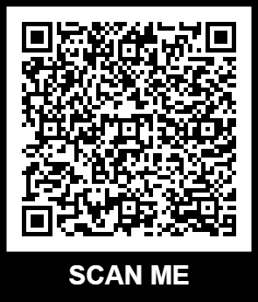

Tickets